Objects and narratives from Mexican roots artists: a Chicana experience

Objetos y narrativas de artistas con raíces mexicanas: una experiencia chicana

Cristina Isabel Castellano González
Universidad de Guadalajara
Centro Universitario de Tonalá
(MÉXICO)
cristinacastellano@hotmail.com

Recibido: 11/12/2016

Revisado: 13/03/2017
Aprobado: 25/04/2017

ABSTRACT

The purpose of this brief article is to discuss the context and the political tensions that existed when women artists with Mexican roots invented a political Chicano art engagé at Los Angeles. We study the creations of Judithe Hernandez and Patssi Valdez, two artists with Mexican roots, who have challenged the codes of the dominant, patriarchal, and white art world of the United States since 1970. As artists, they become a symbol of professional success for women in the arts. They developed personal art expressions and leg their own art vision of America, women, and community. They used streets, walls and displayed public performances. Nevertheless, the originality of this text relies on the analyses of some art pieces from their contemporary period. The text emphasizes the technical transformation of both legendary artists who gave up performance and mural art to develop personal and critical propositions about women condition (myths, femicide) and borders. This text uses methods of art history like image’s description and socio-anthropology methodologies like interviews to understand the singularity of these contemporary artworks.

Keywords: Women. Chicano art. Creation.

RESUMEN

El objetivo de este breve artículo es revisar el contexto y las tensiones políticas que existían cuando mujeres artistas con raíces mexicanas inventaron un arte chicano comprometido y político en Los Ángeles. Estudiaremos las creaciones de Judithe Hernandez y Patssi Valdez, dos artistas con raíces mexicanas, quienes cuestionaron los códigos del dominante mundo del arte patriarcal y blanco en los Estados Unidos de los años setentas. Como mujeres artistas, se volvieron un referente de carreras artísticas exitosas. Las dos artistas estudiadas aquí, desarrollaron expresiones desde los ámbitos personal y colectivo para heredar su visión de Estados Unidos, de las mujeres y de la comunidad a través del arte en las calles, del muralismo y por medio de la ejecución de performances. Sin embargo, la originalidad del presente trabajo estriba en el análisis de algunos de los trabajos del periodo reciente. Este texto enfatiza la transformación técnica de ambas artistas, quienes renunciaron al trabajo artístico en las calles, a los murales y a las performances para concentrarse en el desarrollo de proposiciones artísticas críticas en torno a la condición de las mujeres (mitos, feminicidios) y las fronteras. Se utilizan métodos provenientes de la historia del arte como la descripción de imágenes así como metodologías de la socio-antropología de las artes plásticas como la entrevista, con el objetivo de poder entender la especificidad de sus trabajos artísticos actuales.

Palabras clave: Mujeres. Arte chicano. Creación.

Introduction
The American sociologist Howard Becker demonstrated in his legendary text Art Worlds (1982) that we must think arts in plural ways because the art world is not homogeneous. Artistic expression hinges on contexts, functioning with specific vocabularies, histories, languages, and structures of feelings. Even if this is true, the complex process of hegemony in arts puts the occidental us-euro arts in the first place of the spotlight art news and markets. Occidental art and artists were perceived in the hold twenty century as a mainstream model to follow. In the way to confront this reality, decolonial thinkers with Latin America roots like Gloria Anzaldúa (1987) proved that the creativity from the binational artists provides more than a simple synthesis of cultures. Border artists, especially Chicanos, had been creating with a double schizophrenic feeling of been accepted and rejected because of their “other” roots, race and culture that confronts the mainstream culture from the WASP world in the United States.
In this way, the creativity of the Mexican-American and Chicano artist’s backgrounds has often been confronted with issues of border and cultural exile. Chicanos portray the “suspended roots” cultures of the twenty-one century. The term “suspended roots” was theorized by the French-Martinican writer, philosopher and poet Edouard Glissant (1990) to confront the myth that celebrate the existence of one-root national identity. By moving definitions of class, gender and ethnicity, cultural border artists, Chicana and Mexican artists living in the United States have developed their “own voices” beyond ethnocentrism, conquering both, freedom and imagination. In producing images, they have wanted to see and to tell about themselves and the world.

Los Angeles: open arts lab city
California represents a land of opportunity and free cultural experimentation and migration. In the sixties, California was spending a million dollars a day in the construction of infinite highways (Grenier, 2006). Los Angeles was in boosted economic development as well as representing the capital of the cinematographic industry of the United States. In the field of visual arts, it quarreled its place with New York, but, in what has been called the battle to become the center of art, experts always gave the second place to the border city. Henry Geldzahler explained in Vogue 1964, that San Francisco was sophisticated, cultivated and an european city, whereas Los Angeles was unpolished and missed totally class (Grenier, 2006, p.132). In competing with New York, investors, museums, and art magazines started to support local and alternative exhibitions showing underground subjects connected with new avant-gardes. The star of the American pop art, Andy Warhol, realized his first exhibition in Los Angeles and not in New York. The Ferus Gallery of Irving Bloom exposed from July 9th till August 4th of 1962, the ‘32 Campbell Soups’ and the artist tried to sell them for 100 dollars each (Grenier 2006). The underground art world of Los Angeles encouraged a male generation of new artists who conquered the art market and won their presence in symbolic spaces such as the media and the museums. This Californian art movement and life style was introduced by alternatives places such as the Ferus Gallery, the Syndell Gallery, the Now Gallery and Action I, who were new open art places that used to invite scandalous writers and poets like Jack Kerouac or Paul Ginsberg from the Beat Generation who frequented the underground world to share ideas and perform with visual artists, such as Wallace Berman, the one among many who was frequently censured because of his irreverent work on religion. The radical art of the time struggled against moral intolerance, and opposed the puritanical speeches of conservative America. At the same time, it kept ignoring the reality of the race and class struggles, and the question of hegemony over the minorities of Women, Blacks, and US-Latinos. It was the movement for social rights and the political demonstrations against the Vietnam War to radically change the cultural and artistic venue of California. But the first subjects to react in political and gender terms were the female artists who opened new spaces for women self-expression.

Miriam Shapiro and Judy Chicago
There are two women to quote for the relevance of their artistic engagement. One of the first openly feminist artist in town was Miriam Shapiro, this American artist born in Canada, who worked for the education and the recognition of women in the arts created Big Ox # 1 (1968), a first feminist masterpiece made by a computer. In 1972, she directed the project Womanhouse, a kind of Art School for female artists who were invited to express themselves by using personal subjects and by focusing on the struggles and the conditions of women. The slogan for Shapiro was the famous “the personal is the political”. The group worked as a voluntary and free collective; the artists set up an artistic practice where what was considered as "trivial or commonplace" offered the right material to express the tiniest and most intimate associative memories, souvenirs, of the artists themselves: dolls, pillows, cosmetics, sanitary towels, silk stocking, underwear, children's toys, breads, frying pans, doors, refrigerators, among others (Grenier, 2006, p.236). For this complex construction of femininity, Schapiro invented the term femmage, meaning "the image of the woman"; to this image, it had to be added the "visual newspaper of women", the exportation of the literary genre of the personal ‘diary’ into the arts. Shapiros’ conviction was that women artists held a key into the envisioning of the cultural future of the world, that they had something to say about it.
Another very influential Californian artist of the time was Judy Chicago. She got recognition in the male art world for the originality and provocation of her cartoon of invitation: she appeared standing up in the boxing ring of Muhammad Ali. The photo, printed and sent to the people who frequented galleries, was finally reproduced in full page in ArtForum (Grenier, 2006, p.236). The artist remembers the matter:
This magazine of the men who looked for a fight asked me if I wanted "to fight"… Later I saw the image hung on in studios. I realized that in the 1970s many women lived the same experiences as me. I imagine that the "boxing ring" marked the moment when women through all the country, began to attack the very strong discrimination which reigned in the middle of art. (Chicago, 1996, p.20-33).

These two Californian feminist artists, with many others, developed several projects related to questions and problems concerning women: intimacy, the right to exist, the right to see differently, the right to express oneself by the tools that go with it. They were able to cross the borders of domination by obtaining recognition of their art. Still, their conquests were not ready to cross also the borders of migration, class and ethnicity in the United States. In the seventies, the movement of female artists, together with the laws of affirmative action, granted profits to the artists of Anglo-Saxon origins (Gaspar de Alba 1988). At the same time, it left Mexican, Afro-American, and Asian-American female artists, greatly affected by exile, migration and discrimination, to remain for a long time on the margin of the streets, never to be granted hospitality in galleries or museums.

Mexican-American artists: Judithe Hernandez and Patssi Valdez
Judithe Hernandez and Patssi Valdez are two independent Mexican-American and Chicano artists living in California, today the cradle of ethnic cultural transfers, pleasures, and melting pot lives, the second demographic new immigration city, populated by approximately ten million of Mexicans (Le Texier 2004). Judithe Hernandez and Patssi Valdez are professional artists who live in a milieu where, for a long time, the institutions used to guard the hegemony of art in California, reckoned the Mexican-American artists to be only gangs or hooligans and not artists. Even if their parents were working class migrants, Hernandez and Valdez went to the university in Los Angeles and obtained art diplomas. Nevertheless, “ethnic artists” could and were condemned to paint walls for the municipality, draw posters or realize graffiti, but never produce mainstream art (Tomas Ybarra-Fausto, 2004).
Los Four was the first group to break through the stigmas of the Mexican-American artist in the United States, always to be considered no better than ‘a street painter’. Initially, the group consisted of four male artists: Carlos Almaraz, Gilbert (Magu) Lujan, Roberto (Beto) of Rocha and Frank Romero; the fifth member to become integrated into the group was Judithe Hernandez. Together they created the most famous painted walls of Los Angeles called latter “Neo muralismo del Gran México”. At the beginning of the seventies, the group became the most avant-gardist collective of Chicano art, obtaining international recognition in its critique of the opposition between high culture and popular culture by claiming the chance of an art "In between”. They transformed popular culture and its symbols, transferring them in the contemporary world of art and design. (Castellano, 2004).

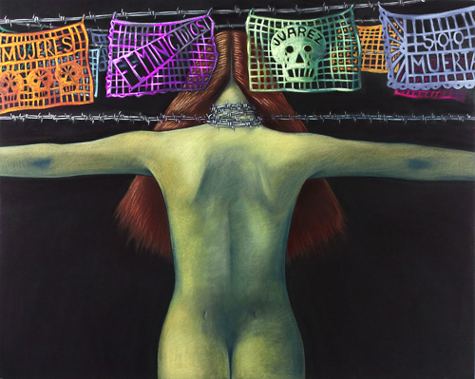
©Judithe Hernandez, Juarez Ciudad de la muerte, 2009
Pastel en papel, colección privada, Juarez Series

Judithe Hernandez was the woman artist in the group, she played one of the most important roles in the advancement of Chicana art. For almost ten years, she had participated with Los Four in the struggle against the clichés stigmatizing the Mexican culture in America. In 1980, she decided to work as an independent and individual artist, inventing a visual vocabulary inspired by her cultural background, worries and sexual identity. Abandoned the streets and the performances, she now paints in her studio, always focusing on the realities and the mythologies of the Mexican migrant women. In the artwork “Juarez Ciudad de la Muerte” (Hernandez 2009), the artist is denouncing the current violence acted out on the most deprived women of the border. Hernandez’s individual artistic approach reveals a very radical representational politics, a voice of resistance against institutional silence.
In “Virgen de las Luchadoras” from Luchadora Series (Hernandez 2008) she plays with the double meaning of the word in Spanish: luchadora that is used for the Mexican female wrestlers in popular culture, and for all the women who “fight” injustice. The artist chooses the narratives of empowerment inspired in mythical beliefs and not the speeches of victims or survivors. Every single painting is a shocking metaphor, an appeasement rite under stress, a ceremony of denunciation and renaissance that links the people who observe them. The brown skin of these women representations in her art evokes the many Mestizas of Latin America, as a philosopher’s stone scanned from the Gloria Anzaldúa’s mind.
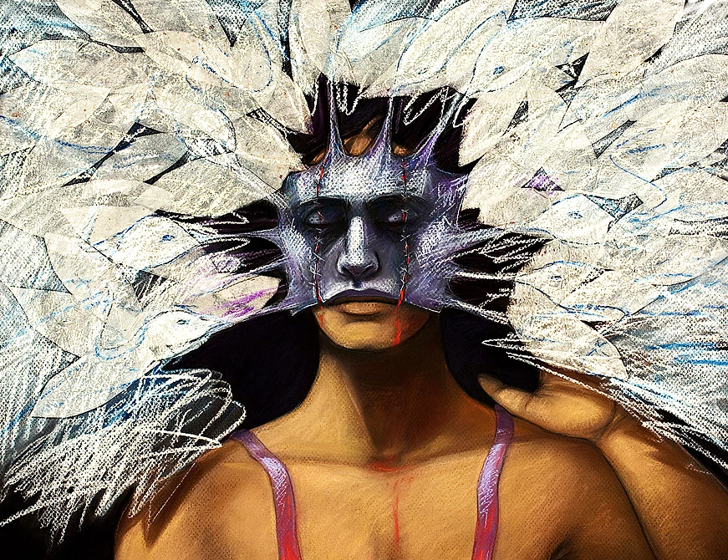
©Judithe Hernandez, Virgen de las Luchadoras, 2008.
Pastel y técnica mixta en papel de archivo, Luchadoras Series

“El castigo de Eva” from the Adam & Eve Series (Hernandez 2010) seeks to represent a “beauty” different from the classical notion of the western civilization. As the artist says :
In the American university, the beauty was the one of the Western Renaissance the mainstream European and American vision was destined to remain incomplete if not thought other specific cultural references, such as those present in Mesoamerican art or those produced by Mexican artists of the stature of Frida Kahlo. (Interview with Judith Hernandez, 26 june 2012).

This artwork also rewrites the biblical figure of mythical Eve, transforming her into an animal, with red and green hands, orange hair, blue body or masks. The artist paints the suffering of Eve and the contemporary resonances that this punishment has with the violence against women in the contemporary world. The first woman in the patriarchal fantasy religion world is placed here intimidated with the metallic bows representative of the borders. Her bandaged eyes and naked body translate women fragility. The mask of woman fighter and the position of the body decode maybe a condition but not a condemnation for the future of the women. Eve appearances here is strong, she does not cry, she does not scream. She is standing there without fear, giving the back to a waterfall of blood and it seems that she is transforming, she is becoming strong like an animal, she is on the way to achieve her freedom.
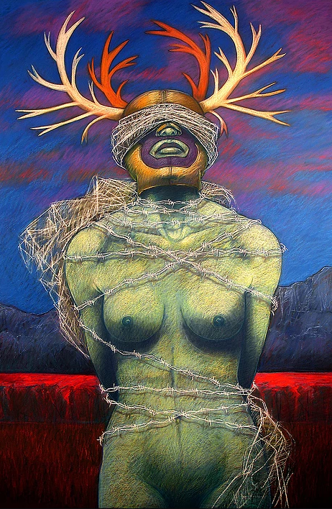
©Judithe Hernandez, El Castigo de Eva, 2010.
Pastel en papel, Serie Adan y Eva
These are only some examples of Judithe Hernandez’s engagement, which, coming from a complete and recognized artist, has always been contemporary. In the sixties, she used her talent to make performances, she then turned to murals in the seventies, and since the eighties she has been using mix-media techniques to make art. Today, to create, she takes advantage of new and different technologies:
I was someone who was never very interested in computers because I did not grow up using them. My early art production was conceived and created using the same traditional methods that artists have used for centuries. So it’s amazing that now that I am nearly 65 years old, I am so grateful to have the computer as another tool to create art! I regularly use Photoshop for my series of “digital portraits”. I also scan my own sketches and other images so I can “play” with the images on the computer to create “versions” of a composition, before I commit to the final drawing. (email interview with Judith Hernandez, 26 june 2012).

Nowadays the use of technology in art and in communication helps engaged artists to expand borderlines. At the same time, to decode contexts in tension and their meanings, arts need aesthetics, cultural studies and epistemologies to study this “other” American art history. Today technologies of communication give free access to discoveries, allowing the circulation of paintings, drawings, prints and digital art. Internet is the privileged tool to explore archives, to research old and contemporary documents or interviews, to establish cultural affinities in forums. Technology changes the politics and the practices of vision, it opens the doors to the discovery of other sensibilities, it links imaginary worlds inside and outside the spaces of exile. There are not technical borders to learn about engaged arts.
Another woman artist who played a major role in this milieu was Patssi Valdez. At the seventies, she was working with ASCO, the famous Chicano artists’ collective. ASCO was created by Gronk, Willie Herron III, Harry Gamboa Jr., and Patssi Valdez. Even if all the members of the group were graduated from schools of art, they were mainly considered as street artists-punks because they lived in the East "dangerous districts” of Los Angeles, and they were often rejected by galleries and museums because of their "ethnic" profiles. In response, ASCO decided to tag the walls of Los Angeles County Museum of Art, not as an act of vandalism but as an act of protest racial discrimination. Today, the photographs of this performance represent a masterpiece of Chicano art, and all the individual artists of the group are recognized in the Chicano market of art.
After a decade of work in public spheres, in the eighties, Patssi Valdez began to create in a studio. Her field of intervention was not performances or murals any longer. To develop her personal universe, she decided to work with painting, gouaches, ceramics, and screen-printing. But she explains that Chicano culture is part of her structure of feeling, constituting her source of inspiration:
My paintings portray an actual and or imagined place that depict an inspirational or emotionally charged feeling or experience. They are snippets of environments that I consider meaningful and symbolic of my individual as well as collective Chicano experience. (Valdez, 2012)

For Valdes, who had developed for a long time her aesthetic approach in the "outside" space of the street (performance) and of the wall (murals), the move to the intimate space of the studio realized her most imminent desire. Maybe this is the reason why her colored and mysterious imagination brought to the foreground the figure of the ‘house’, a subject more and more present in her work. Because of her Chicana multiple identity, born in America but still felling Mexican, Valdez painted a "different American house”, a house "in between", where the outside and the inside were confused as an integrated and fragmented imaginary (Castellano 2007). In Valdez’s art, the house is the designated place to be recognized. The French philosopher Gaston Bachelard thought the house as “one of the possible places for the construction of the self” (1957). The houses painted by Patssi Valdez presented a childish character, embellished by jewels. The windows open towards a sunny and bright horizon, with lamps switched on by the inside of the house.
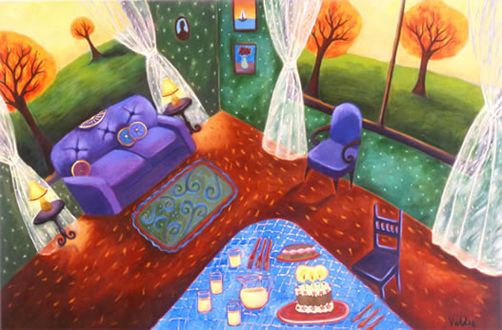
©Patssi Valdez, Happy birthday, 2000, acrylic on canvas

It is difficult to understand if the work takes places during daylight or at night, if the walls are showing the garden, or if everything is about painting boards. In this moving house, time stops, and the borderline of the wall fades in a circular gesture, the movement is marked by perspective; the birthday cakes and the candles evoke expectation and waiting; the tables, sofas and glasses of lemonades announce anonymous guests. The house is "opened" to hospitality. It is an artistic proposal that erases the paradoxes of Derrida’s hospitality, a process of confrontation and of recognition of otherness. Valdez’ houses are ready and dressed up to celebrate. The motto of the Mexican popular culture “mi casa es tu casa” is there, but the reception of the guests is conditioned by the glance of the hostess.
The approach of Judith Hernandez and Patssi Valdez prove that women of a mexican culture living in the United States can exceed domination and anticipate creation against mainstream art. The two artists work against all hegemonic tendencies in the American official world of art, overtaking the dichotomies between the private and public spheres, the street and the house, the inside and the outside. Their aesthetic strategies deconstruct patriarchal orders, showing an imagination in constant transformation, always opened to cultural and artistic exchanges. It matters little that, still now, in the face of their extraordinary achievements, the history of official art remains deaf to their magnificent artistic expressions

Referencias
Anzaldúa, G. (1987). Borderlands. La Frontera. San Francisco: The New Mestiza, Spinters/Aunt. Lute.
Bachelard, G. (1957). La poétique de l’espace. París: PUF, 10 edición.
Becker, H. (1982). Art Worlds. California: The University of California Press.
Castellano, C. (2004). Les querelles de l’art chicano. Thule, Rivista Italiana Di Studi Americanistici, No. 16/17 (53-66). Perugia: Centro Studi Americanistici “Circolo Amerindiano” ARGO.
______. (2007). Imaginarios Fragmentados. Padilla, Chavolla (Eds.) La Seducción Simbólica (213-233). Buenos Aires: Prometeo.
Chicago, J. (1996). Beyond the Flower: Autobiography of a Feminist Artist. Los Angeles on 1955-1985. Birth os an artistic capital (20-33). París: Museum of Modern Art Georges Pompidou Center.
Gaspar de Alba, A. (1988). Chicano Art. Inside/Outside the Master´s house. Ausatin : The University of Texas Press.
Glissant, E. (1990). Poétique de la Relation, París: Gallimard.
Grenier, C. (2006). Los Angeles on 1955-1985. Birth of an artistic capital. París: Museum of Modern Art Georges Pompidou Center.
Le Texier, E. (2004). Des millions des sans-papiers mexicains aux États-Unis : vers une régularisation. Hommes & Migrations. (68-74). París: Revista de la Cité National de l’histoire de l’immigration.
Hernandez, J. (2009). Juarez Ciudad de la Muerte. Rubro Galleries, apartado Juarez Series. Obtenido el 01/05/2017. http://www.judithehernandez.com
______. (2008) Virgen de las Luchadoras. Rubro Galleries, apartado Luchadoras Series. Obtenido el 01/05/2017. http://www.judithehernandez.com
______. (2010) El Castigo de Eva, Rubro Galleries, apartado The Adam and Eve Series. Obtenido el 01/05/2017. http://www.judithehernandez.com
Valdez. P. (2012) Rubro Biografía. Obtenido el 02/09/ 2012.
http://www.patssivaldez.com/
Ybarra-Fausto, T. (2004). Transnational imaginaries: Mexico-United States. París: Coloquio sobre La Experiencia Mestiza, 3 de abril, Auditorio del Museo del Louvre.

